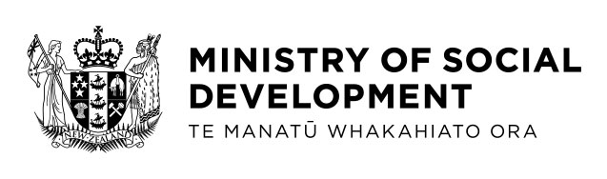

Employment Service in Schools

The Ministry of Social Development (MSD) and the Ministry of Education (MOE) are working together to pilot Employment Service in Schools (ESiS) for disabled students who plan to leave school within the next two years.

The service is for young people who face barriers to employment because of a disability or health condition. This includes young people whose needs have been identified as neurodiverse.

The pilot is an expansion of the current MSD-funded Employment Service and will work in collaboration with students, whānau, schools and kura to provide support for up to 1000 disabled young people.

The aims of the service are to promote employment as the best option for when the students leave their school or kura, to encourage employment related training, and to increase work preparedness.

Employment Service in Schools is an alternative to the current Transition Service offered by MSD. If students are ORS funded and eligible for the Transition Service, they can choose to take part in either the Transition Service or ESiS but they cannot be enrolled in both at the same time.

The pilot will be in schools from term one 2021 and run until end of June 2022. It will be in parts of Auckland, Waikato, Wellington, Canterbury and Otago/Southland. The first group of local schools who have been identified and other schools are welcome to join in the future.

Workshops will be held in the five main centres in March for ESiS providers, whānau, schools, kura and students to get together to co-design how the service will work and be most effective in their region.

If you would like to know more, please email Employment_Service_in_Schools@msd.govt.nz and your query will be answered by the right person.

